Robot Framework(with minimal code )

🡪generic automation framework for acceptance testing(more business users will involve )

🡪python 3on windows machine

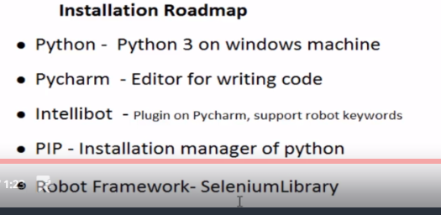

C:\Python27

C:\>python -V

Python 2.7.15

1)install python set environment variables

2)Install 🡪pycharm community version

Create project –exAutomation1

In pycharam editor we can write python code

3)install intellibot plugin

To write robot framework code in pycharm we need to install intellibot

Open pycharm –settings

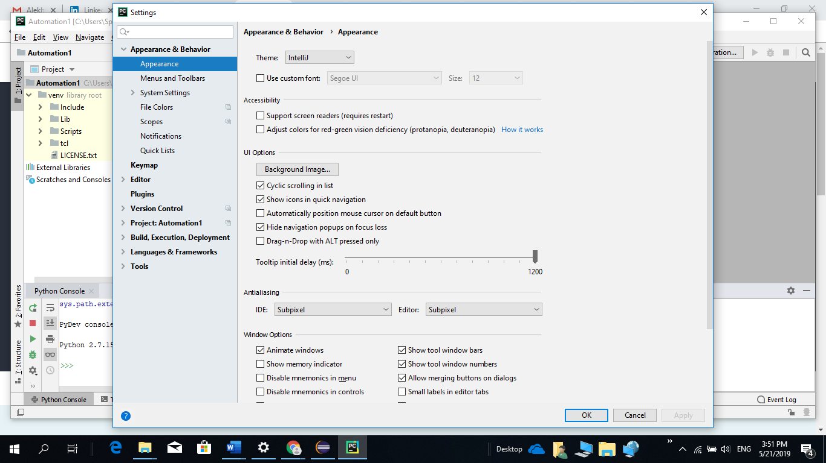

**Search for plugin –intellibot to support Robot framework**

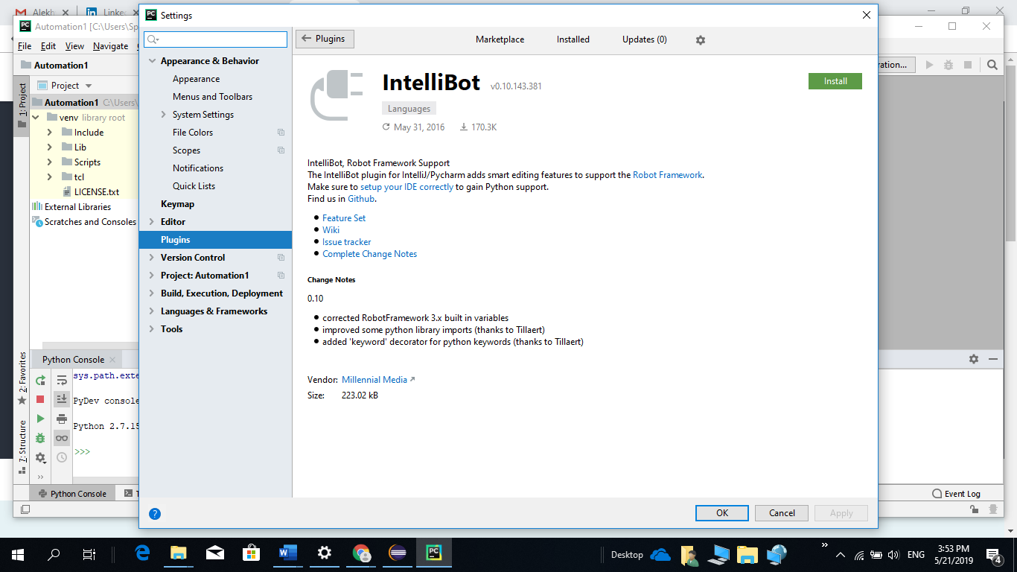

**Click on install**

Python code files --.py

C:\Python27\python.exe C:\Users\Username\Desktop\my_python_script.py

File 🡪create 🡪new 🡪 robot framework

Need to create file with .robot extension

Right click on robot framework 🡪new file🡪tc_001.robot

Type **** ctrl +space -- settings (Remove 3 stars)

Settings area – we can write config info

Variables – to declare variables

create first testcase in robot framework:

create robot file

create sections

define libraries

define variables

write tc

Tc_Start_cose.robot –

**\*\*\* Settings ***  
*Library*** *SeleniumLibrary***\*\*\* Variables ***  
${Browser}** *Chrome***${URL}** *https://www.klm.com/home/nl/en***\*\*\* Test Cases ***  
TC_001 Browser start and close** Open Browser ${URL} ${Browser}

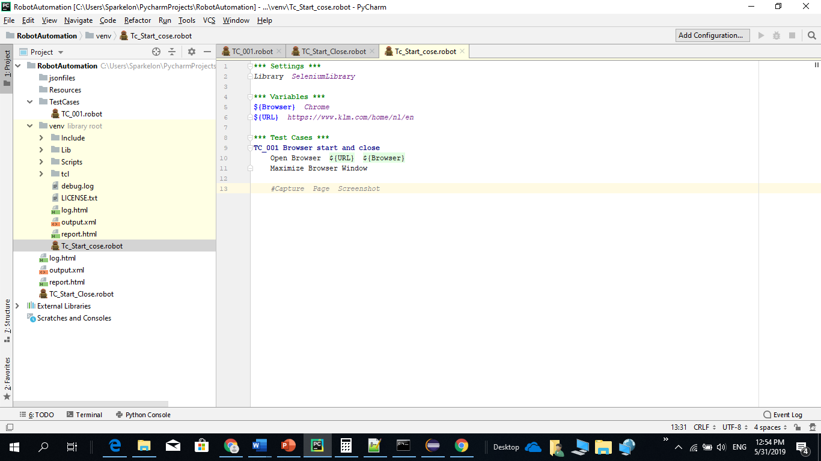

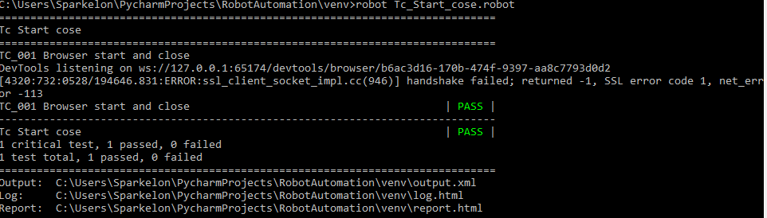

C:\Users\Sparkelon\PycharmProjects\RobotAutomation\venv

Run code : robot Tc_start_cose.robot

**While writing code**

If we get error Open Browser like below code will work to fix this uninstall intelliBot and restart IDE

Then install intellibot@seleniumLibrary..

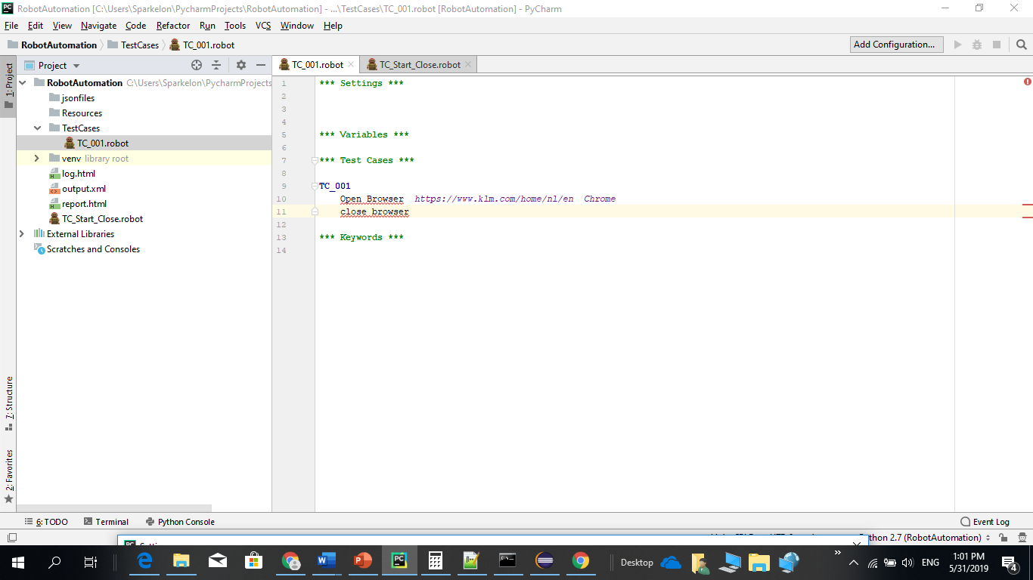

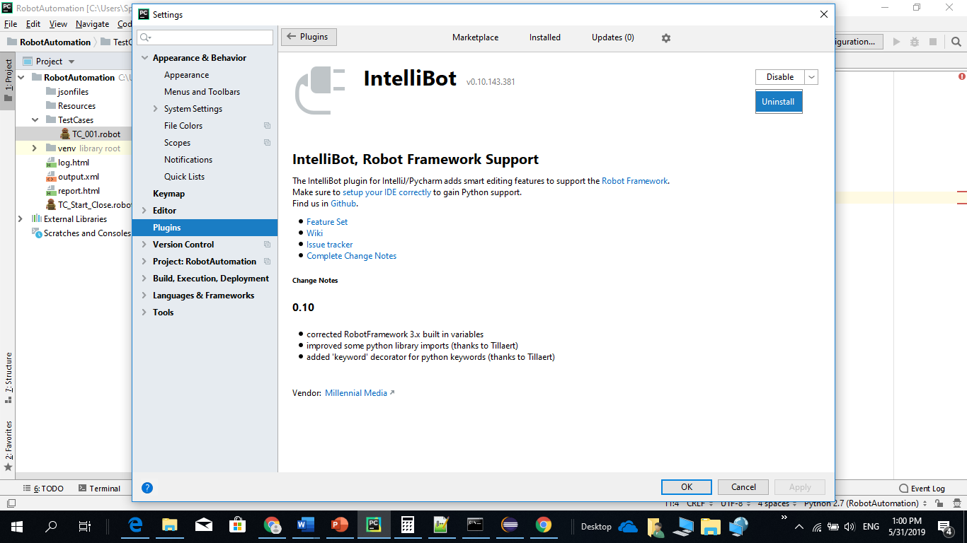

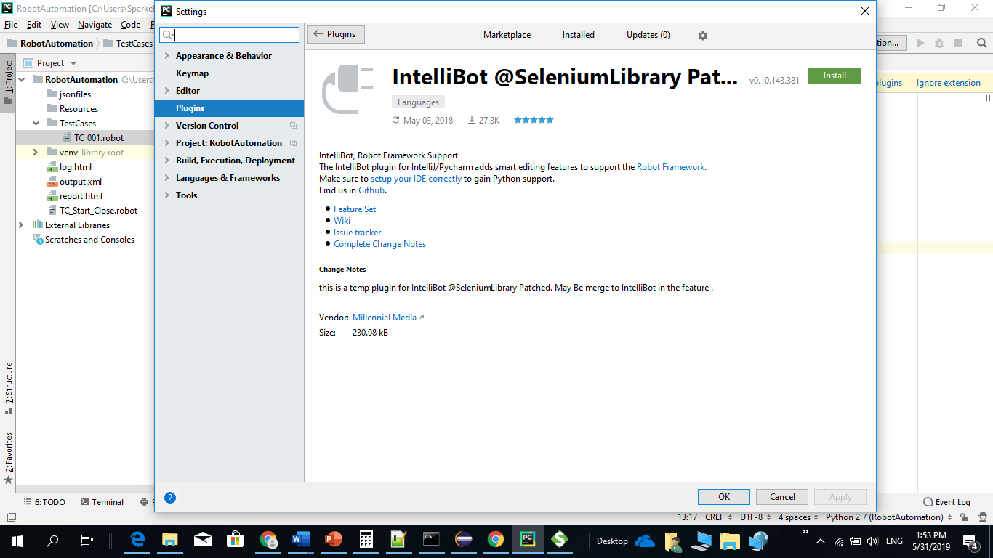

My current configs:  
Python 3.7.0  
PyCharm 2018.2.4 CE  
robotframework 3.0.4  
robotframework-seleniumlibrary 3.2.0  
selenium 3.14.1

RED:

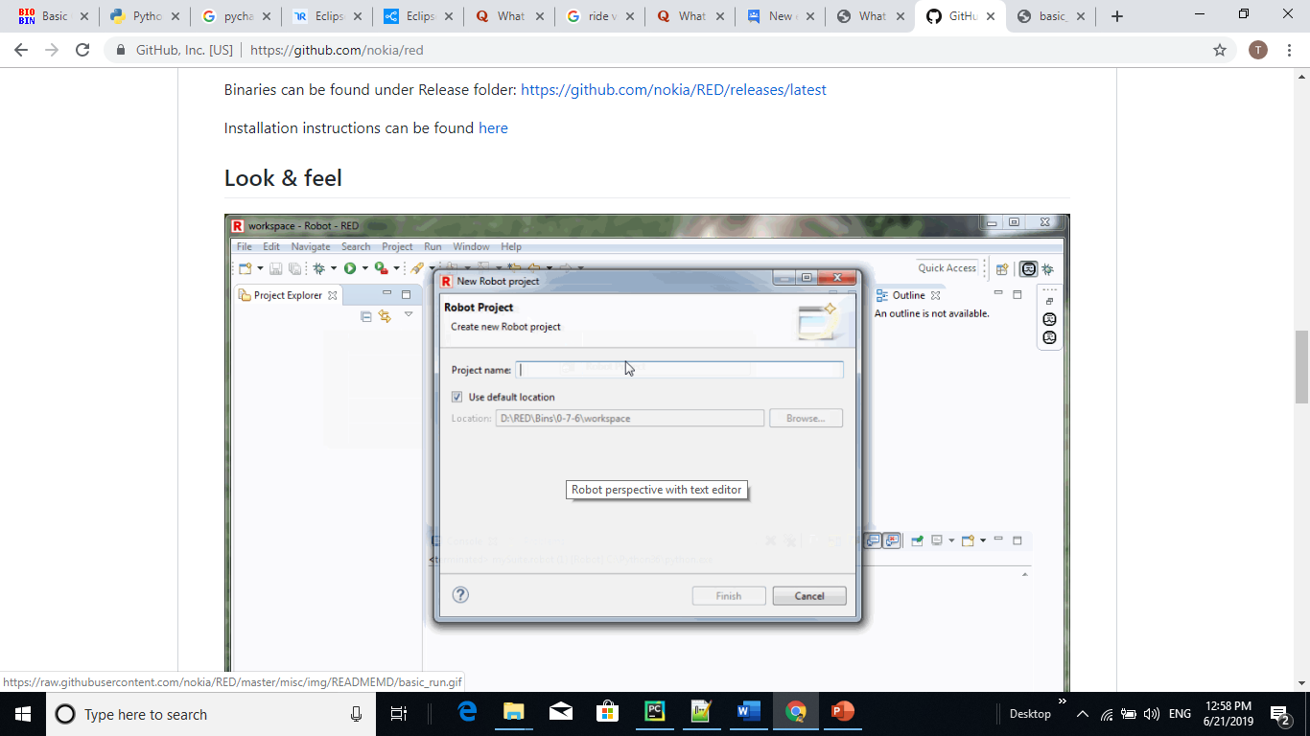

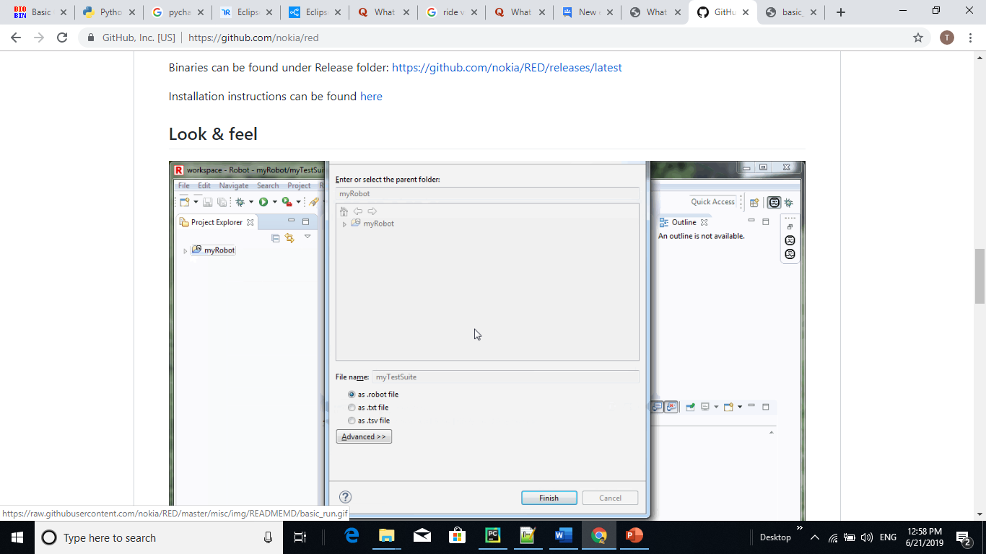

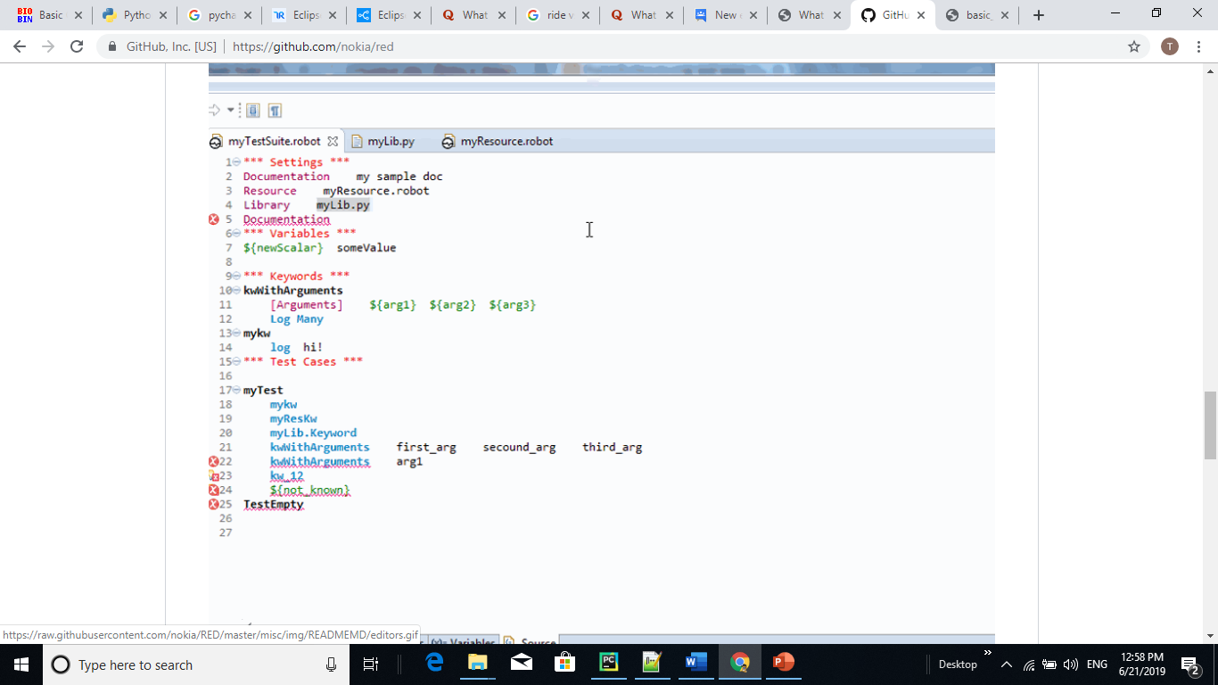

RIDE:

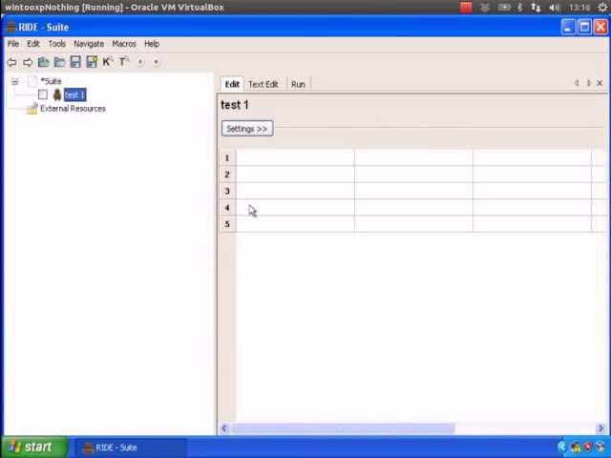

Python in Eclipse:

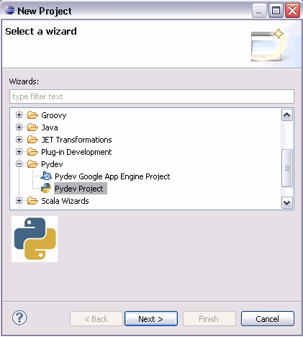

Create new project and select interpreter

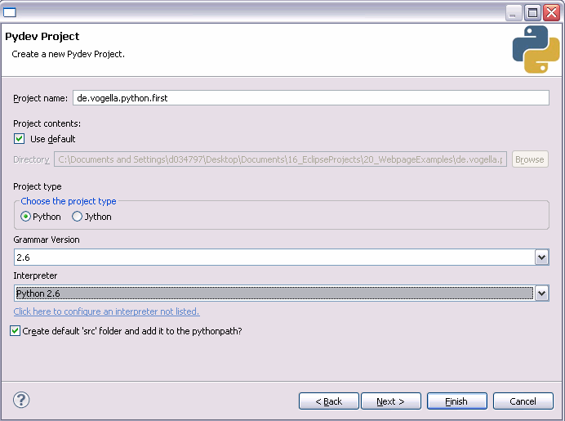

Select **Window**  **Open Perspective**  **Other**. Select the PyDev perspective.

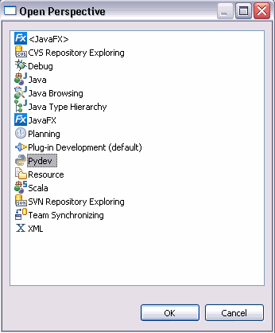

Select the "src" folder of your project, right-click it and select New → PyDev Modul. Create a module "FirstModule"

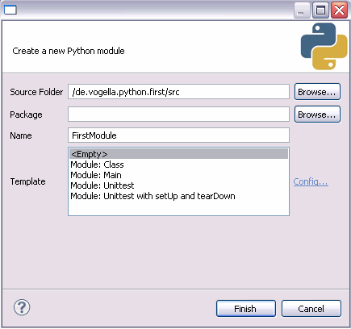

Create the following source code.

**'''**

**Created on 18.06.2009**

**@author: Lars Vogel**

**'''**

**def** add(a,b):

**return** a**+**b

**def** addFixedValue(a):

y **=** **5**

**return** y **+**a

**print** add(**1**,**2**)

**print** addFixedValue(**1**)

Right-click your model and select Run As → Python run.

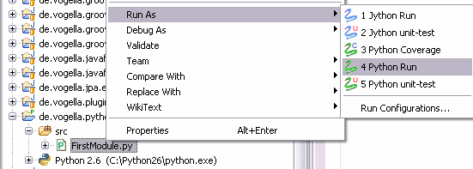

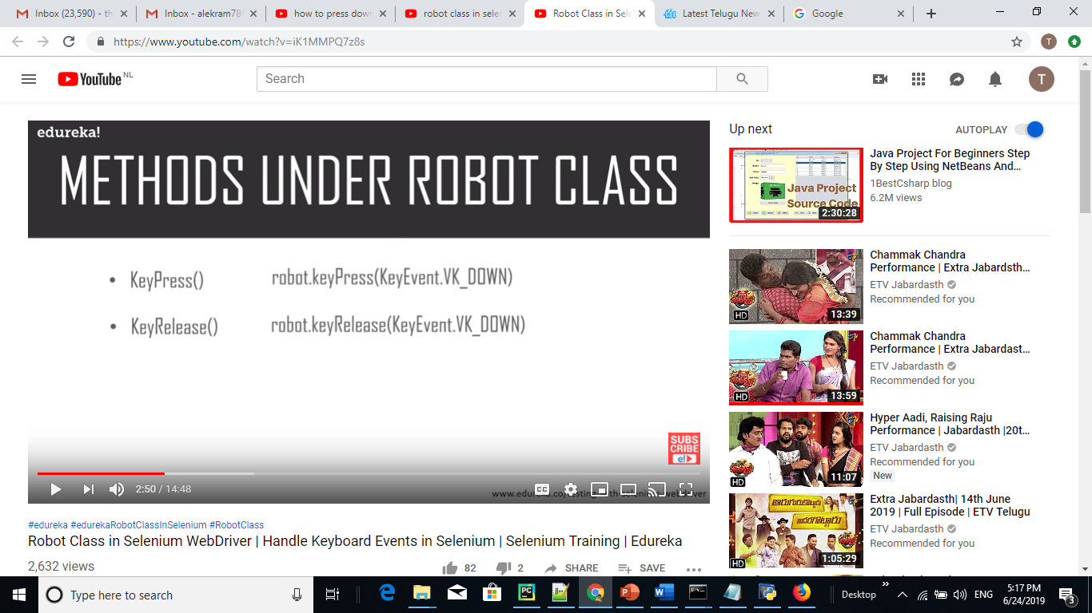

*********

For loop in robot framework

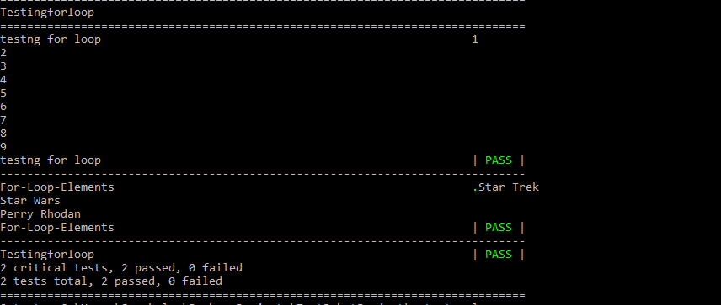

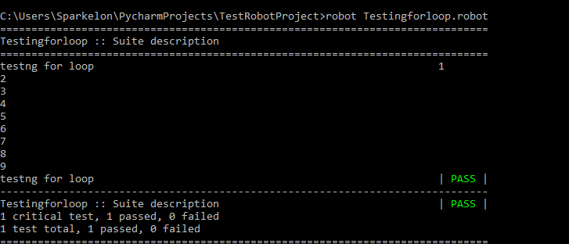

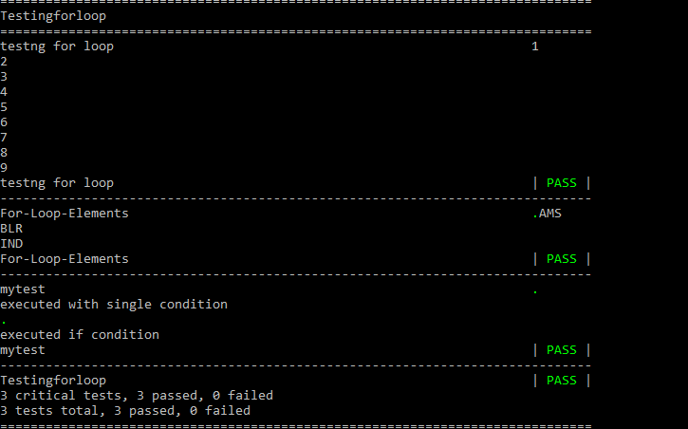

**Customize keyword in Python:**

**Created commontool.py place this under lib folder of python local path**

Ride disav – cannot workwith python3

Ride needs wxpython whichis not compatible with macos

